Analysis of Building Frames (Using Kani’s Method)
Gasper Kani, a German engineer, developed another distribution procedure based on slope deflection equations. This method is very useful for the analysis of multistorey frames. The greatest advantage of this method is, even if a mistake is committed in distribution in one of the cycles, it converges finally to the correct answer. Even today, many practising engineers who are not familiar with computer methods, use Kani's method for the analysis of 3 to 4 storey building frames.
This method is first explained for structures with fixed ends. Then, the modifications to handle simply supported and overhanging ends are discussed. Analysis of symmetric frames making use of the symmetry is also explained, after which an analysis of general frames is taken up.
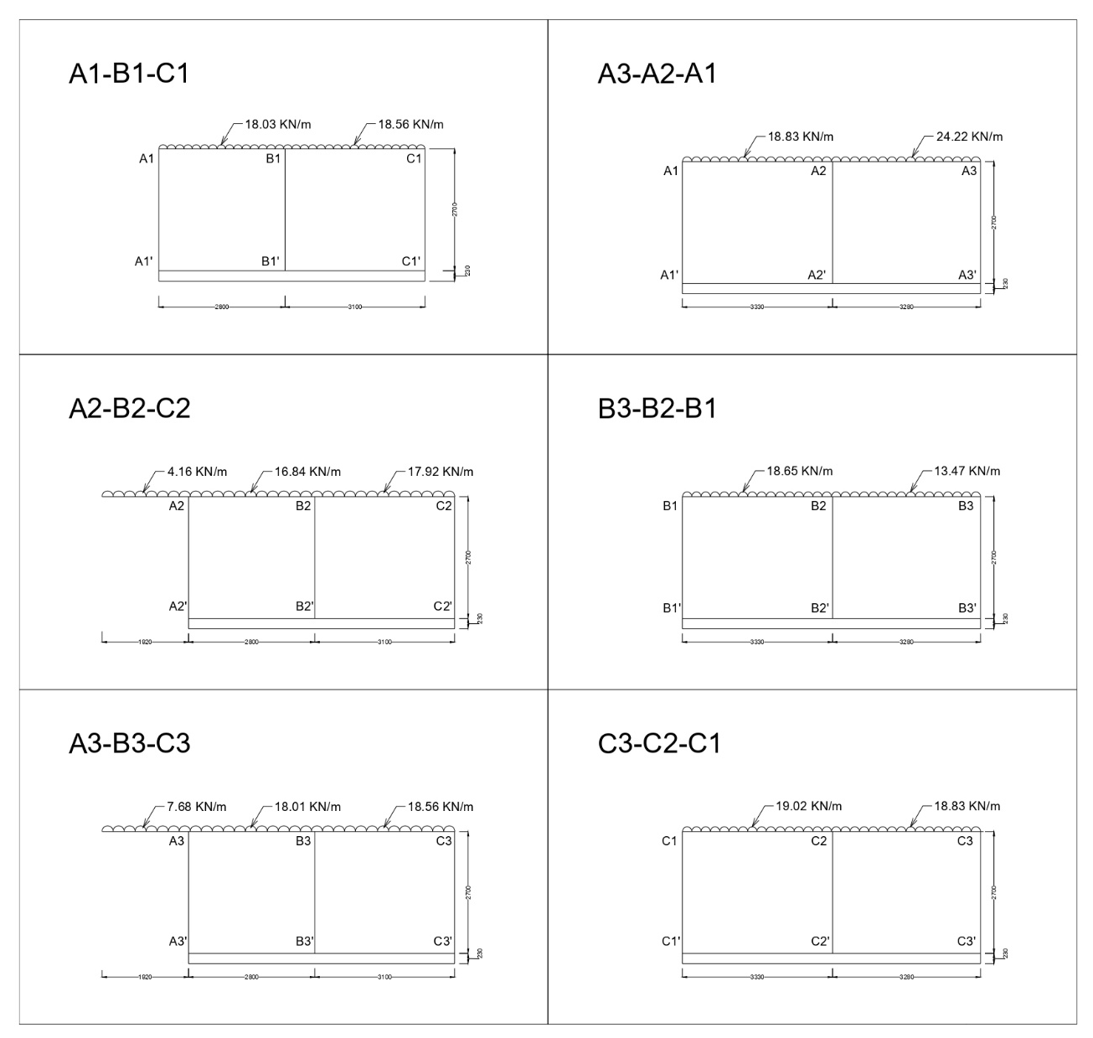
Figure 1: Beam Layout
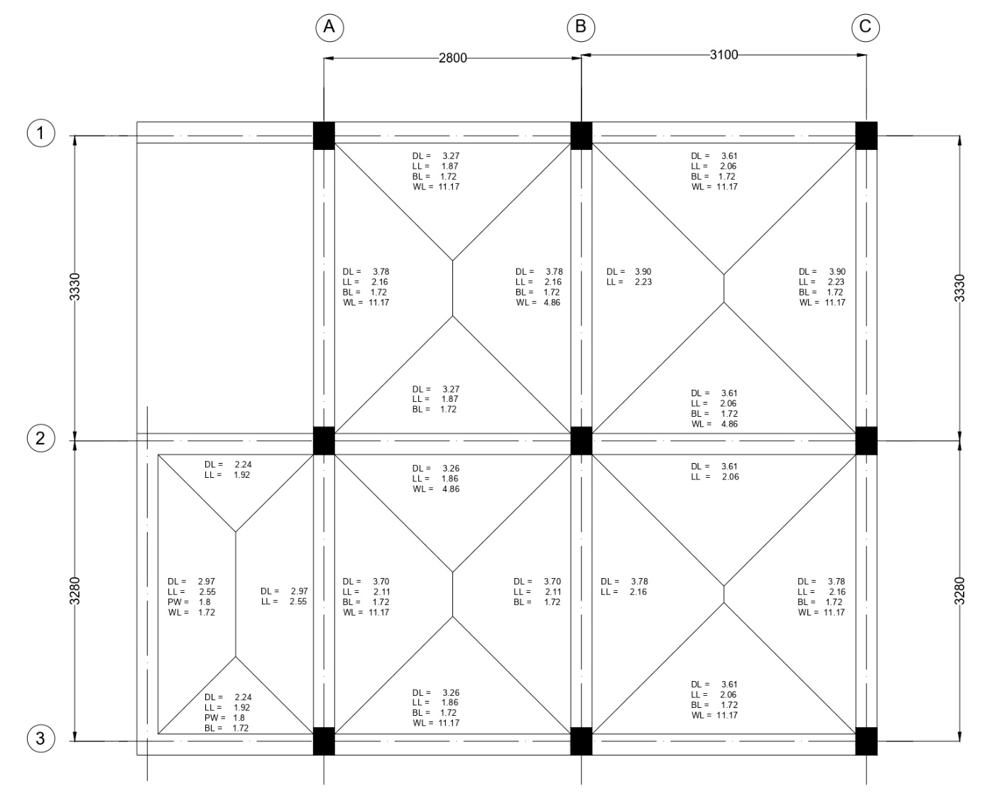
Figure 2: Frames.

Analysis of Frame C1-C2-C3
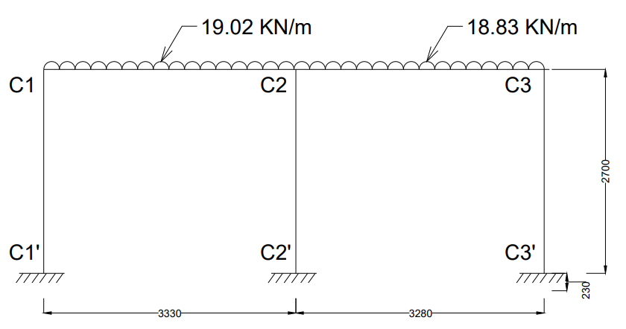
Step 1: Fixed End Moments
MF_{C1C2} = $\frac{-{WL}^{2}}{12}$ = $\frac{-19.02 × {3.33}^{2}}{12}$ = -17.58 KN-m
MF_{C2C1} = $\frac{{WL}^{2}}{12}$ = $\frac{19.02 × {3.33}^{2}}{12}$ = +17.58 KN-m
MF_{C2C3} = $\frac{-{WL}^{2}}{12}$ = $\frac{-18.83 × {3.28}^{2}}{12}$ = -16.88 KN-m
MF_{C3C2} = $\frac{{WL}^{2}}{12}$ = $\frac{18.83 × {3.28}^{2}}{12}$ = +16.88 KN-m
Fixed end moments in All the columns are zero.
i.e,
MF_{C1C1՛ =} MF_{C1՛C1} = MF_{C2C2՛ =} MF_{C2՛C2 =} MF_{C3C3՛ =} MF_{C3՛C3} = 0

Step 2: Rotation Factor $\left(R.F = -\frac{1}{2} \left(\frac{k}{Σk}\right) \right)$, $\left(k= \frac{4EI}{L}\right)$
Joints | Members | Stiffness ($k$) | $$Σk$$ | R.F
C1 | C1C2 | 1.201EI | 2.682EI | -0.224
C1 | C1C1՛ | 1.481EI | 2.682EI | -0.276
C2 | C2C1 | 1.201EI | 3.902EI | -0.154
C2 | C2C3 | 1.220EI | 3.902EI | -0.156
C2 | C2C2՛ | 1.481EI | 3.902EI | -0.190
C3 | C3C2 | 1.220EI | 2.701EI | -0.226
C3 | C3C3՛ | 1.481EI | 2.701EI | -0.274

Stiffness ($k$) $\left(k=\left(\frac{4EI}{L}\right)\right)$
K_{C1C2} = $\left(\frac{4EI}{3.33}\right)$ = 1.201EI
K_{C1C1՛} = $\left(\frac{4EI}{2.7}\right)$ = 1.481EI
K_{C2C1} = $\left(\frac{4EI}{3.33}\right)$ = 1.201EI
K_{C2C3} = $\left(\frac{4EI}{3.28}\right)$ = 1.220EI
K_{C2C2՛} = $\left(\frac{4EI}{2.7}\right)$ = 1.481EI
K_{C3C2} = $\left(\frac{4EI}{3.28}\right)$ = 1.220EI
K_{C3C3՛} = $\left(\frac{4EI}{2.7}\right)$ = 1.481EI
Sum of Stiffness ∑$k$ at Joints
C1: 1.201EI + 1.481EI = 2.682EI
C2: 1.201EI + 1.220EI + 1.481EI = 3.902EI
C3: 1.220EI + 1.481EI = 2.701EI
Rotation Factor $\left(R.F = -\frac{1}{2} \left(\frac{k}{Σk}\right) \right)$
R.F_{C1C2} = $-\frac{1}{2} \left(\frac{1.201}{2.682EI}\right)$ = -0.224
R.F_{C1C1՛} = $-\frac{1}{2} \left(\frac{1.481EI}{2.682EI}\right)$= -0.276
R.F_{C2C1} = $-\frac{1}{2} \left(\frac{1.201EI}{3.902EI}\right)$ = -0.154
R.F_{C2C3} = $-\frac{1}{2} \left(\frac{1.220EI}{3.902EI}\right)$ = -0.156
R.F_{C2C2՛} = $-\frac{1}{2} \left(\frac{1.481EI}{3.902EI}\right)$ = -0.190
R.F_{C3C2} = $-\frac{1}{2} \left(\frac{1.220EI}{2.701EI}\right)$ = -0.226
R.F_{C3C3՛} = $-\frac{1}{2} \left(\frac{1.481EI}{2.701EI}\right)$ = -0.274

Step 3: Displacement Factor $\left(D.F = -\frac{3}{2} \left(\frac{k}{Σk}\right) \right)$
Storey | Members | $$k$$ | $$Σk$$ | D.F
1 | C1C1՛ | 1.481EI | 4.444EI | -0.5
1 | C2C2՛ | 1.481EI | 4.444EI | -0.5
1 | C3C3՛ | 1.481EI | 4.444EI | -0.5

Stiffness ($k$) $\left(k=\left(\frac{4EI}{L}\right)\right)$
K_{C1C1՛} = $\left(\frac{4EI}{2.7}\right)$ = 1.481EI
K_{C2C2՛} = $\left(\frac{4EI}{2.7}\right)$ = 1.481EI
K_{C3C3՛} = $\left(\frac{4EI}{2.7}\right)$ = 1.481EI
Sum of Stiffness ∑$k$ at Storey
∑$k$ = 1.481EI + 1.481EI + 1.481EI = 4.444EI
Displacement Factor $\left(D.F = -\frac{3}{2} \left(\frac{k}{Σk}\right) \right)$
D.F_{C1C1՛} = $-\frac{3}{2} \left(\frac{1.481EI}{4.444EI}\right)$= -0.5
D.F_{C2C2՛} = $-\frac{3}{2} \left(\frac{1.481EI}{4.444EI}\right)$ = -0.5
D.F_{C3C3՛} = $-\frac{3}{2} \left(\frac{1.481EI}{4.444EI}\right)$ = -0.5

Rotation and Displacement Contribution

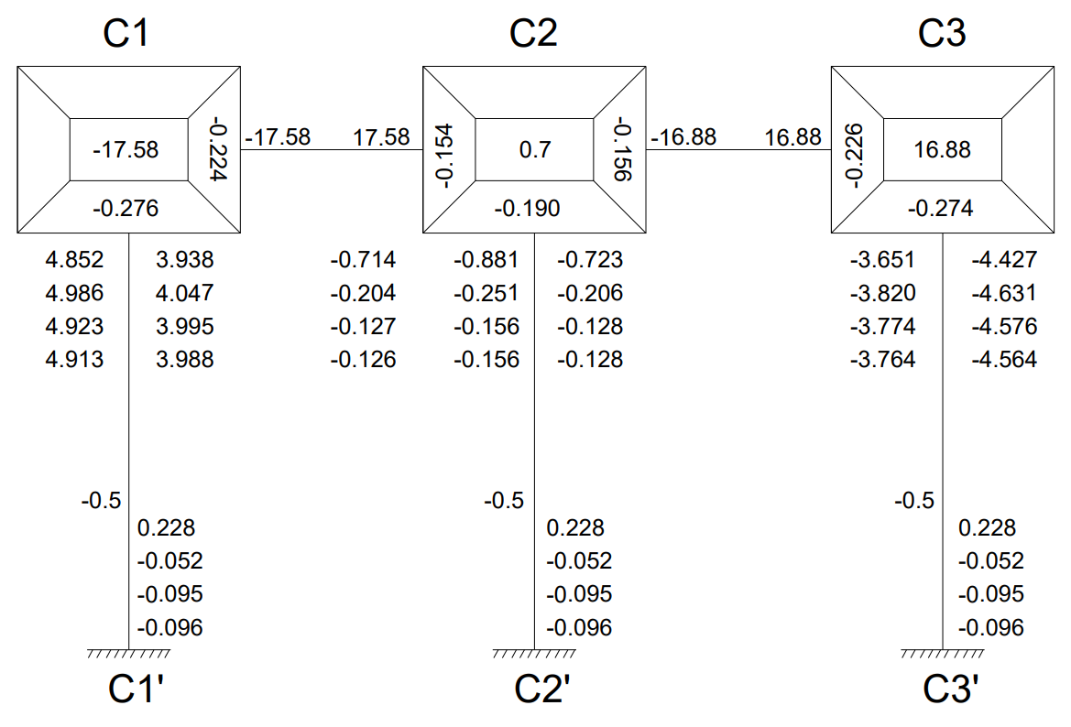
Cycle 1
Joint Rotation $\left(C.V. = R.F × \left[∑FEM+NCV+FCV\right]\right)$
M_{C1C2} = -0.224 × [-17.58 + 0 + 0] = 3.938
M_{C1C1՛} = -0.276 × [-17.58 + 0 + 0] = 4.852
M_{C2C1} = -0.154 × [0.7 + 3.938 + 0] = -0.714
M_{C2C3} = -0.156 × [0.7 + 3.938 + 0] = -0.723
M_{C2C2՛} = -0.190 × [0.7 + 3.938 + 0] = -0.881
M_{C3C2} = -0.226 × [16.88 + (-0.723) + 0] = -3.651
M_{C3C3՛} = -0.274 × [16.88 + (-0.723) + 0] = -4.427
Displacement Contribution
For All Columns $\left(R.V. = D.F × \left[∑Rotations Contribution at Columns\right]\right)$
M_{C1C1՛} = M_{C2C2՛} = M_{C3C3՛} = -0.5 $×$ (4.852 + (-0.881) + (-4.427)) = 0.228

Cycle 2
Joint Rotation $\left(C.V. = R.F × \left[∑FEM+NCV+FCV\right]\right)$
M_{C1C2} = -0.224 × [-17.58 + 0.228 + (-0.714)] = 4.047
M_{C1C1՛} = -0.276 × [-17.58 + 0.228 + (-0.714)] = 4.986
M_{C2C1} = -0.154 × [0.7 + 0.228 + 4.047 + (-3.651)] = -0.204
M_{C2C3} = -0.156 × [0.7 + 0.228 + 4.047 + (-3.651)] = -0.206
M_{C2C2՛} = -0.190 × [0.7 + 0.228 + 4.047 + (-3.651)] = -0.251
M_{C3C2} = -0.226 × [16.88 + 0.228 + (-0.206)] = -3.820
M_{C3C3՛} = -0.274 × [16.88 + 0.228 + (-0.206)] = -4.631
Displacement Contribution
For All Columns $\left(R.V. = D.F × \left[∑Rotations Contribution at Columns\right]\right)$
M_{C1C1՛} = M_{C2C2՛} = M_{C3C3՛} = -0.5 $×$ (4.986 + (-0.251) + (-4.631)) = -0.052

Cycle 3
Joint Rotation $\left(C.V. = R.F × \left[∑FEM+NCV+FCV\right]\right)$
M_{C1C2} = -0.224 × [-17.58 + (-0.052) + (-0.204)] = 3.995
M_{C1C1՛} = -0.276 × [-17.58 + (-0.052) + (-0.204)] = 4.923
M_{C2C1} = -0.154 × [0.7 + (-0.052) + 3.995 + (-3.820)] = -0.127
M_{C2C3} = -0.156 × [0.7 + (-0.052) + 3.995 + (-3.820)] = -0.128
M_{C2C2՛} = -0.190 × [0.7 + (-0.052) + 3.995 + (-3.820)] = -0.156
M_{C3C2} = -0.226 × [16.88 + (-0.052) + (-0.128)] = -3.774
M_{C3C3՛} = -0.274 × [16.88 + (-0.052) + (-0.128)] = -4.576
Displacement Contribution
For All Columns $\left(R.V. = D.F × \left[∑Rotations Contribution at Columns\right]\right)$
M_{C1C1՛} = M_{C2C2՛} = M_{C3C3՛} = -0.5 $×$ (4.923 + (-0.156) + (-4.576)) = -0.095

Cycle 4
Joint Rotation $\left(C.V. = R.F × \left[∑FEM+NCV+FCV\right]\right)$
M_{C1C2} = -0.224 × [-17.58 + (-0.095) + (-0.127)] = 3.988
M_{C1C1՛} = -0.276 × [-17.58 + (-0.095) + (-0.127)] = 4.913
M_{C2C1} = -0.154 × [0.7 + (-0.095) + 3.988 + (-3.774)] = -0.126
M_{C2C3} = -0.156 × [0.7 + (-0.095) + 3.988 + (-3.774)] = -0.128
M_{C2C2՛} = -0.190 × [0.7 + (-0.095) + 3.988 + (-3.774)] = -0.156
M_{C3C2} = -0.226 × [16.88+ (-0.095) + (-0.128)] = -3.764
M_{C3C3՛} = -0.274 × [16.88 + (-0.095) + (-0.128)] = -4.564
Displacement Contribution
For All Columns $\left(R.V. = D.F × \left[∑Rotations Contribution at Columns\right]\right)$
M_{C1C1՛} = M_{C2C2՛} = M_{C3C3՛} = -0.5 $×$ (4.913 + (-0.156) + (-4.564)) = -0.096

Step 4: Final End Moments
M_{ij} = FEM + 2×M_{ij} (Near end Rotation) + M_{ji} (Far end Rotation) +M՛՛ (Displacement)
Beams (No Sway M՛՛= 0)
M_{C1C2} = -17.58 + 2(3.988) + (-0.126) = -9.73
M_{C2C1} = 17.58 + 2(-0.126) + 3.988 = 21.31
M_{C2C3} = -16.88 + 2(-0.128) + (-3.764) = -20.9
M_{C3C2} = 16.88 + 2(-3.764) + (-0.128) = 9.22
Column (With Sway M՛՛= (-0.096))
M_{C1C1՛} = 0 + 2(4.913) + 0 + (-0.096) = 9.73
M_{C1՛C1} = 0 + 2(0) + 4.913 + (-0.096) = 4.82
M_{C2C2՛} = 0 + 2(-0.156) + 0 + (-0.096) = -0.41
M_{C2՛C2} = 0 + 2(0) + (-0.156) + (-0.096) = -0.25
M_{C3C3՛} = 0 + 2(-4.564) + 0 + (-0.096) = -9.22
M_{C3՛C3} = 0 + 2(0) + (-4.564) + (-0.096) = -4.66
Equilibrium Check
Joint C1 = M_{C1C2} + M_{C1C1՛} = -9.73 + 9.73 = 0
Joint C2 = M_{C2C1} + M_{C2C3՛ +} M_{C2C2՛} = 21.31 + (-20.9) + (-0.41) = 0
Joint C3 = M_{C3C2} + M_{C3C3՛} = 9.22 + (-9.22) = 0
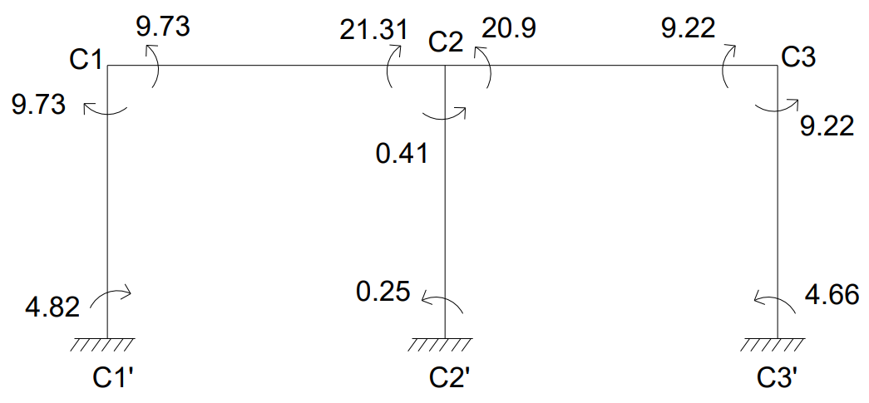
CALCULATION BENDING MOMENT
BM_{C1C2} = $\frac{{WL}^{2}}{8}$ = $\frac{{19.02 ×3.33}^{2}}{8}$ = 26.36KN-m
BM_{C2C3} = $\frac{{WL}^{2}}{8}$ = $\frac{{18.83 ×3.28}^{2}}{8}$ = 25.32KN-m
BENDING MOMENT DIAGRAM
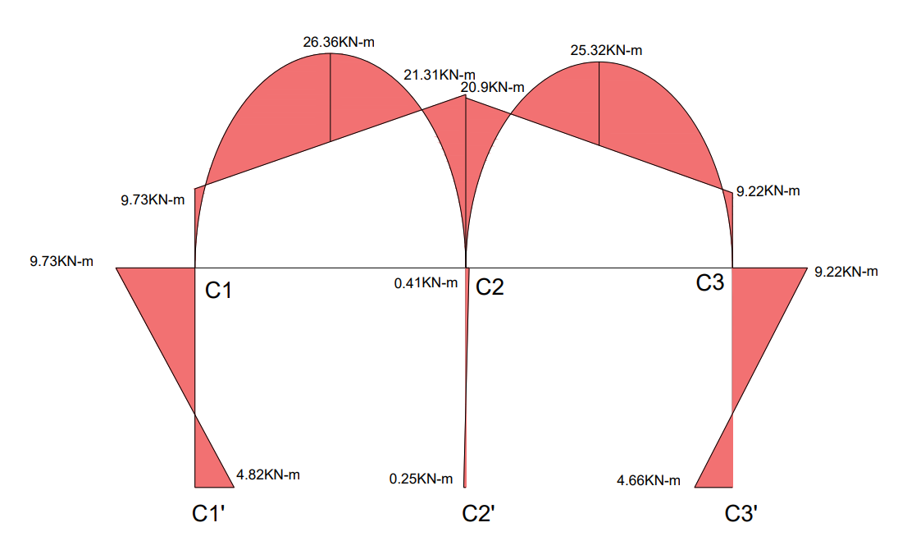
CALCULATION OF REACTIONS
SPAN C1-C2
Length (L) = 3.33m, UDL (W) = 19.02KN/m
Simply Supported Reactions:
R_{total} = $\frac{WL}{2}$ = $\frac{19.02 ×3.33}{2}$ = 31.67KN
Reaction Due to End Moments:
R_{moments} = $\frac{M_{C2C1}- M_{C1C2}}{L}$ = $\frac{21.31 - 9.73}{3.33}$ = 3.48KN
Final Reactions:
R_{C1} = R_{total} – R_{moments} = 31.67 – 3.48 = 28.19KN
R_{C2(Left)} = R_{total} + R_{moments} = 31.67 + 3.48 = 35.15KN

SPAN C2-C3
Length (L) = 3.28m, UDL (W) = 18.83KN/m
Simply Supported Reactions:
R_{total} = $\frac{WL}{2}$ = $\frac{18.83 ×3.28}{2}$ = 30.88KN
Reaction Due to End Moments:
R_{moments} = $\frac{M_{C2C3}- M_{C3C2}}{L}$ = $\frac{20.9- 9.22}{3.28}$ = 3.56KN
Final Reactions:
R_{C2(Right)} = R_{total} + R_{moments} = 30.88 + 3.56 = 34.44KN
R_{C3}= R_{total} – R_{moments} = 30.88 – 3.56 = 27.32KN
Total Reactions:
Reaction at Column C1 (R_{C1}) = 28.19KN
Reaction at Column C2 (R_{C2}) = R_{C2(Left)} + R_{C2(Right)} = 35.15 + 34.44 = 69.59KN
Reaction at Column C3 (R_{C3}) = 27.32KN

